**Project Planning Phase**

**Project Planning Template (Product Backlog, Sprint Planning, Stories, Story points)**

|  |  |
| --- | --- |
| Date | june 2025 |
| Team ID | LTVIP2025TMID48073 |
| Project Name | Visualizing Housing Market Trends An Analysis of Sale Prices and Features using Tableau |
| Maximum Marks | 5 Marks |

**Product Backlog, Sprint Schedule, and Estimation (4 Marks)**

Use the below template to create product backlog and sprint schedule

| **Sprint** | **Functional Requirement (Epic)** | **User Story Number** | **User Story / Task** | **Story Points** | **Priority** |
| --- | --- | --- | --- | --- | --- |
| Sprint-1 | Registration | USN-1 | As a user, I can register for the application by entering my email, password, and confirming my password. | 2 | High |
| Sprint-1 | Registration | USN-2 | As a user, I will receive confirmation email once I have registered for the application | 1 | High |
| Sprint-2 | Registration | USN-3 | As a user, I can register for the application through Facebook | 2 | Low |
| Sprint-1 | Registration | USN-4 | As a user, I can register for the application through Gmail | 2 | Medium |
| Sprint-1 | Login | USN-5 | As a user, I can log into the application by entering email & password | 1 | High |
| Sprint-2 | Dashboard | USN-6 | As a user, I can view a summary of housing trends in a visual dashboard. | 3 | High |
| Sprint-2 | Dashboard | USN-7 | As a user, I can filter housing data by price, location, and type. | 3 | Medium |
| Sprint-3 | Dashboard | USN-8 | As a user, I can download the report in PDF/Excel format. | 2 | Low |

**Project Tracker, Velocity & Burndown Chart: (4 Marks)**

| **Sprint** | **Total Story Points** | **Duration** | **Sprint Start Date** | **Sprint End Date (Planned)** | **Story Points Completed (as on Planned End Date)** | **Sprint Release Date (Actual)** |
| --- | --- | --- | --- | --- | --- | --- |
| Sprint-1 | 20 | 6 Days | 24 Oct 2022 | 29 Oct 2022 | 20 | 29 Oct 2022 |
| Sprint-2 | 20 | 6 Days | 31 Oct 2022 | 05 Nov 2022 | 18 | 06 Nov 2022 |
| Sprint-3 | 20 | 6 Days | 07 Nov 2022 | 12 Nov 2022 | 15 | 13 Nov 2022 |
| Sprint-4 | 20 | 6 Days | 14 Nov 2022 | 19 Nov 2022 | 20 | 19 Nov 2022 |

Velocity Calculation:

|  |  |  |  |
| --- | --- | --- | --- |
| **Sprint** | Story Points Completed | Duration (Days) | Velocity (Points/Day) |
| Sprint-1 | 20 | 6 | 3.33 |
| Sprint-2 | 18 | 6 | 3.00 |
| Sprint-3 | 15 | 6 | 2.50 |
| Sprint-4 | 20 | 6 | 3.33 |

**Average Velocity (AV)**

AV=43.33+3.00+2.50+3.33​=412.16​=3.04 story points/day

**Burndown Chart:**

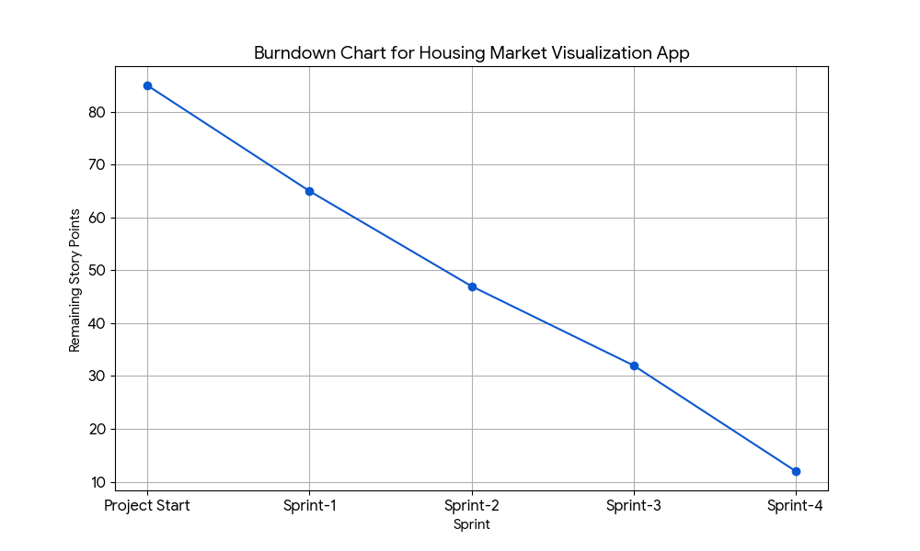A burn down chart is a graphical representation of work left to do versus time. It is often used in agile[software development](https://www.visual-paradigm.com/scrum/what-is-agile-software-development/) methodologies such as [Scrum](https://www.visual-paradigm.com/scrum/scrum-in-3-minutes/). However, burn down charts can be applied to any project containing measurable progress over time.

**Here's the data for the burndown chart:**

We'll start with the total story points for the project and subtract the completed story points after each sprint.

| End of Sprint | Story Points Completed in Sprint | Cumulative Story Points Completed | Remaining Story Points |
| --- | --- | --- | --- |
| Project Start | - | 0 | 85 |
| Sprint-1 | 20 | 20 | 85−20=65 |
| Sprint-2 | 18 | 20+18=38 | 85−38=47 |
| Sprint-3 | 15 | 38+15=53 | 85−53=32 |
| Sprint-4 | 20 | 53+20=73 | 85−73=12 |